

BOBP-IGO
The BOBP-IGO is providing many supports to ADSGAF for carrying out its activities. ADSGAF is taking this opportunity to thank Dr. Y.S. Yadava
for his patronage.
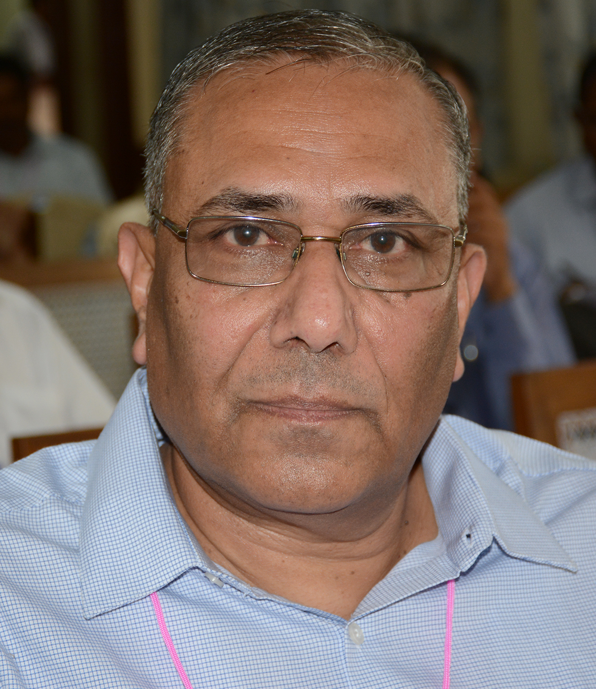
Member of our Advisory Board

Dr. Yugraj Yadava, Ph.d
Director
Bay of Bengal Programme IGO
91, St Mary’s Road
Abhiramapuram
Chennai – 600 018, Tamil Nadu, INDIA
Tel: +91 44 24936188; Cell: +9841042235
Fax: +91 44 24936102
Email: yugraj.yadava@bobpigo.org

