Solar Powered Refrigerated Trucks for
Transportation of Fresh Fish

1.0 Background

The dispersed and distant living population requires proper means for food preservation and distribution without its spoilage. The existing food preservation and transportation technology has developed sufficiently to preserve the wide variety of foods for a considerable long time without loosing the freshness. In the case of fish, a highly perishable commodity needs best preservation and transportation to avoid spoilage and to maintain freshness. This is significantly enhancing the costs—both capital and operational. Association of Deep Sea Going Artisanal Fishermen (ADSGAF) is currently exploring means of reducing the operational expenses of refrigerated transport using solar power.

- Introduction

This is a pilot project based on the experiment and experience acquired by ADSGAF since 2010. By using solar photovoltaic cell technology on the fishing boats, fisher members of ADSGAF could save fuel, money and time. Besides, fishermen are able to fish using the solar powered lights and communication systems and devices resulting in the reduction of carbon emission. The on-board solar power system for fishing boats project is being presently supported by NABARD for scaling up and to further broaden and replicate this experiment.

In this present envisaged project we are proposing to use the solar technology on fish transport vehicles for active refrigeration to preserve the various fish species that are being transported to various distant, domestic and export markets without compromising the quality and freshness.

The current experiment will be conducted in one insulated van equipped with compressors of domestic refrigerator. Solar panels will be installed on top of the van, and the batteries, charge controller and an inverter will be installed inside the van.

3.0 The experiments of ADSGAF, BOBP-IGO and Jagath Jothi Solar Energy Private Limited.

The ADSGAF in collaboration with the Bay of Bengal Programme Inter-Governmental Organisation (BOBP-IGO) and M/s Jagath Jothi Solar Energy Private Ltd. have been conducting trials on the practical usage of solar energy in fishing crafts since early 2010. Based on the success achieved in the initial trials, we have now embarked on the second stage of our pilot-scale activities with the objective of establishing effective models that can demonstrate the successful application of solar energy in fishing boats and other land-based applications in the fisheries sector. In fishing boats, such applications at this stage includes the use of solar energy for most of the auxiliary functions such as signal lights; charging of communication devices, navigation and entertainment equipment on board; lighting of storage /cooking/wheelhouse areas; use of additional lights during night fishing operations and hauling of nets; etc.

4.0 On-Board Solar Power for Transport Vehicle: a Demonstration

The most challenging aspect of fish transportation by sea or by road is the maintenance of the cold chain, for upholding the quality of the product and the optimisation of the packing and stowage density. Maintaining the cold chain requires the use of insulated containers on transport vehicles and adequate quantities of coolants for mechanical refrigeration. Generally such type of transport vehicles will be operating in fossil fuel and the same will be used for the operation of refrigeration mechanism. However, as fish is highly perishable, sufficient cooling is necessary to preserve it. Traditionally, ice is used for preserving fish during transportation. However, increasing cost of ice and increasing cost of fuel as in case of a modern refrigerated van for transportation is posing a major challenge.

Recently ADSGAF conducted a demonstration using a Tata Ace vehicle fitted with 170 litre refrigeration system with a compressor load of 1200 Watts for transportation of fish procured from different centres to distant fish markets. This refrigeration system had been powered by four solar panels of 75 watts each (300Watts), installed on the top of the unit. This experiment/demonstration seemed to be feasible and adaptable. This innovative and creative idea was conceptualised, designed and mooted out by ADSGAF and the subsequent technical solution for the demonstration was provided by Jagath Jothi Solar Energy (P) Ltd and the demonstration was sponsored by BOBP-IGO.

- Current Problems

The current problems related with the existing fish transport systems are mentioned below:-

- Non availability of suitable fish transport vehicles
- Fish Merchants are operating with only profit motive and not quality conscious
- High rent of fish transport vehicles
- Frequent power cut leading to ice shortage
- Frequent power cut leading to higher cost of ice.
- Non availability of fully formed ice

6.0 The Project

It is a general reading and understanding that for the running of an active refrigerated van, the diesel requirement is 20% higher than the normal operation of a normal insulated van.

Normally all the insulated transportation fish carrier vehicles depend on diesel as the source of power using customised gensets for the refrigeration purposes in the transit and stationery mode for maintaining the freshness of the fish which is a perishable commodity.

There had never been precedence in the application or adaptation of solar powered refrigeration till date in the transport of the fish species. We are, therefore, inclined to try a way out to experiment in fish transportation using solar energy to power the refrigeration based on our recent experiments conducted in Thoothoor using the solar power onboard our fishing vessels, which had been a success story and we are fine-tuning the trials for better performance and replication.

We intent to adapt solar energy for refrigerating the fish in the insulated van on stationery stock take-in mode and also on transit mode. We are hopeful and optimistic that a considerable amount of dependence on fossil fuel (currently diesel power in use) will be reduced, thereby minimising the carbon emission paving the way for a sustainable and green systems application.

Moreover the diesel powered insulated vehicles have to run their engines to source the power for the refrigeration to be active on both stationery status and also in transit using considerable amount of fuel increasing the expenditure. If solar energy is applied for this purpose the expenditure in this aspect will be reduced thereby generating an additional income. This application is directly improving the economy of the operation of the vehicle. From environment point of view, it is, definitely, reducing the carbon foot-print.

We envisage procuring one new one tonne capacity transport carriers manufactured by leading companies in this field. The body of the vehicle will be re-modified for the installation of PUF. A three kilowatt (kw) solar power system which includes the components of inverter, power charge controllers, batteries along with the photo-voltaic panels with suitable frames and structures will be installed on the roof top of the vehicle. This will be the source of energy for the refrigeration system inside the vehicle.

- Rationale

Methodical, apt and timely technological interventions in post harvest activities and operations in Fisheries, subsequent to fish production is a cardinal activity in terms of value addition, additional income generation and provision of healthy and hygienic sea food protein to millions of people.

Moreover, the time for adaptation of solar energy in the preservation of fish is also an imminent and an important factor as the climate change crisis is escalating with the carbon emission on the increase day by day with the application and usage of fossil fuel in all aspects of fish production and post harvesting activities.

Green fish preservation techniques in the field of refrigeration during fish transportation trips to near and far transit markets is relevant to the times and time tested refrigeration technology sourcing the renewable solar energy power has to be introduced to lower the carbon emission levels and to reduce the carbon footprint in fisheries.

The transportation vehicles that are engaged in fish transportation are using the conventional method of fish preservation in their insulated vans. Once they shift to solar energy for the refrigeration purpose, there will be concerted efforts to replicate and adapt this clean and green energy as it benefits the fisheries in particular and the mankind in general. Hence, the need for highlighting a proven solar technology in refrigeration for the preservation of fish is to be developed and show-cased.

8.0 Expected Outcome

A suitable and environment friendly transporting system for fresh fish transportation will be evolved and the consumers would be able to access quality fish species and further it will also help fishermen to get better price for their fishing effort and their capital investment.

Two thousand (2000) fishermen from Tamil Nadu and Puducherry States will be benefitted annually through this project.

This will also be an opportunity to show-case the ‘solar energy systems application’ in post harvest activities and finally the mitigation of climate change crisis.

9.0 Future course of action and sustainability factors

As planned, the project period ends in August 2015.The last Monitoring Committee meeting scheduled in Jun 2015 will evaluate and analyse the project implementation and will decide the further course of action. The proposed suggestion would be to identify suitable women self-help groups in the sector to shoulder the responsibility of running the insulated truck in a sustainable manner generating an additional income and paving the way for replication and dissemination of this solar powered refrigerated technology in the sector.

10.0 Conclusion

The post harvest technologies are poised for a change in the near future whatsoever. We need to act accordingly to the changing needs of the times where the carbon emission and the subsequent damages are visible in all the sectors all over the world. The ‘solar powered refrigeration systems application’ would end up as one of the solutions for environment friendly fish preservation practices in post harvesting activities in the fisheries sector.
***

On-Board Solar Power for Transport Vehicle: a Demonstration

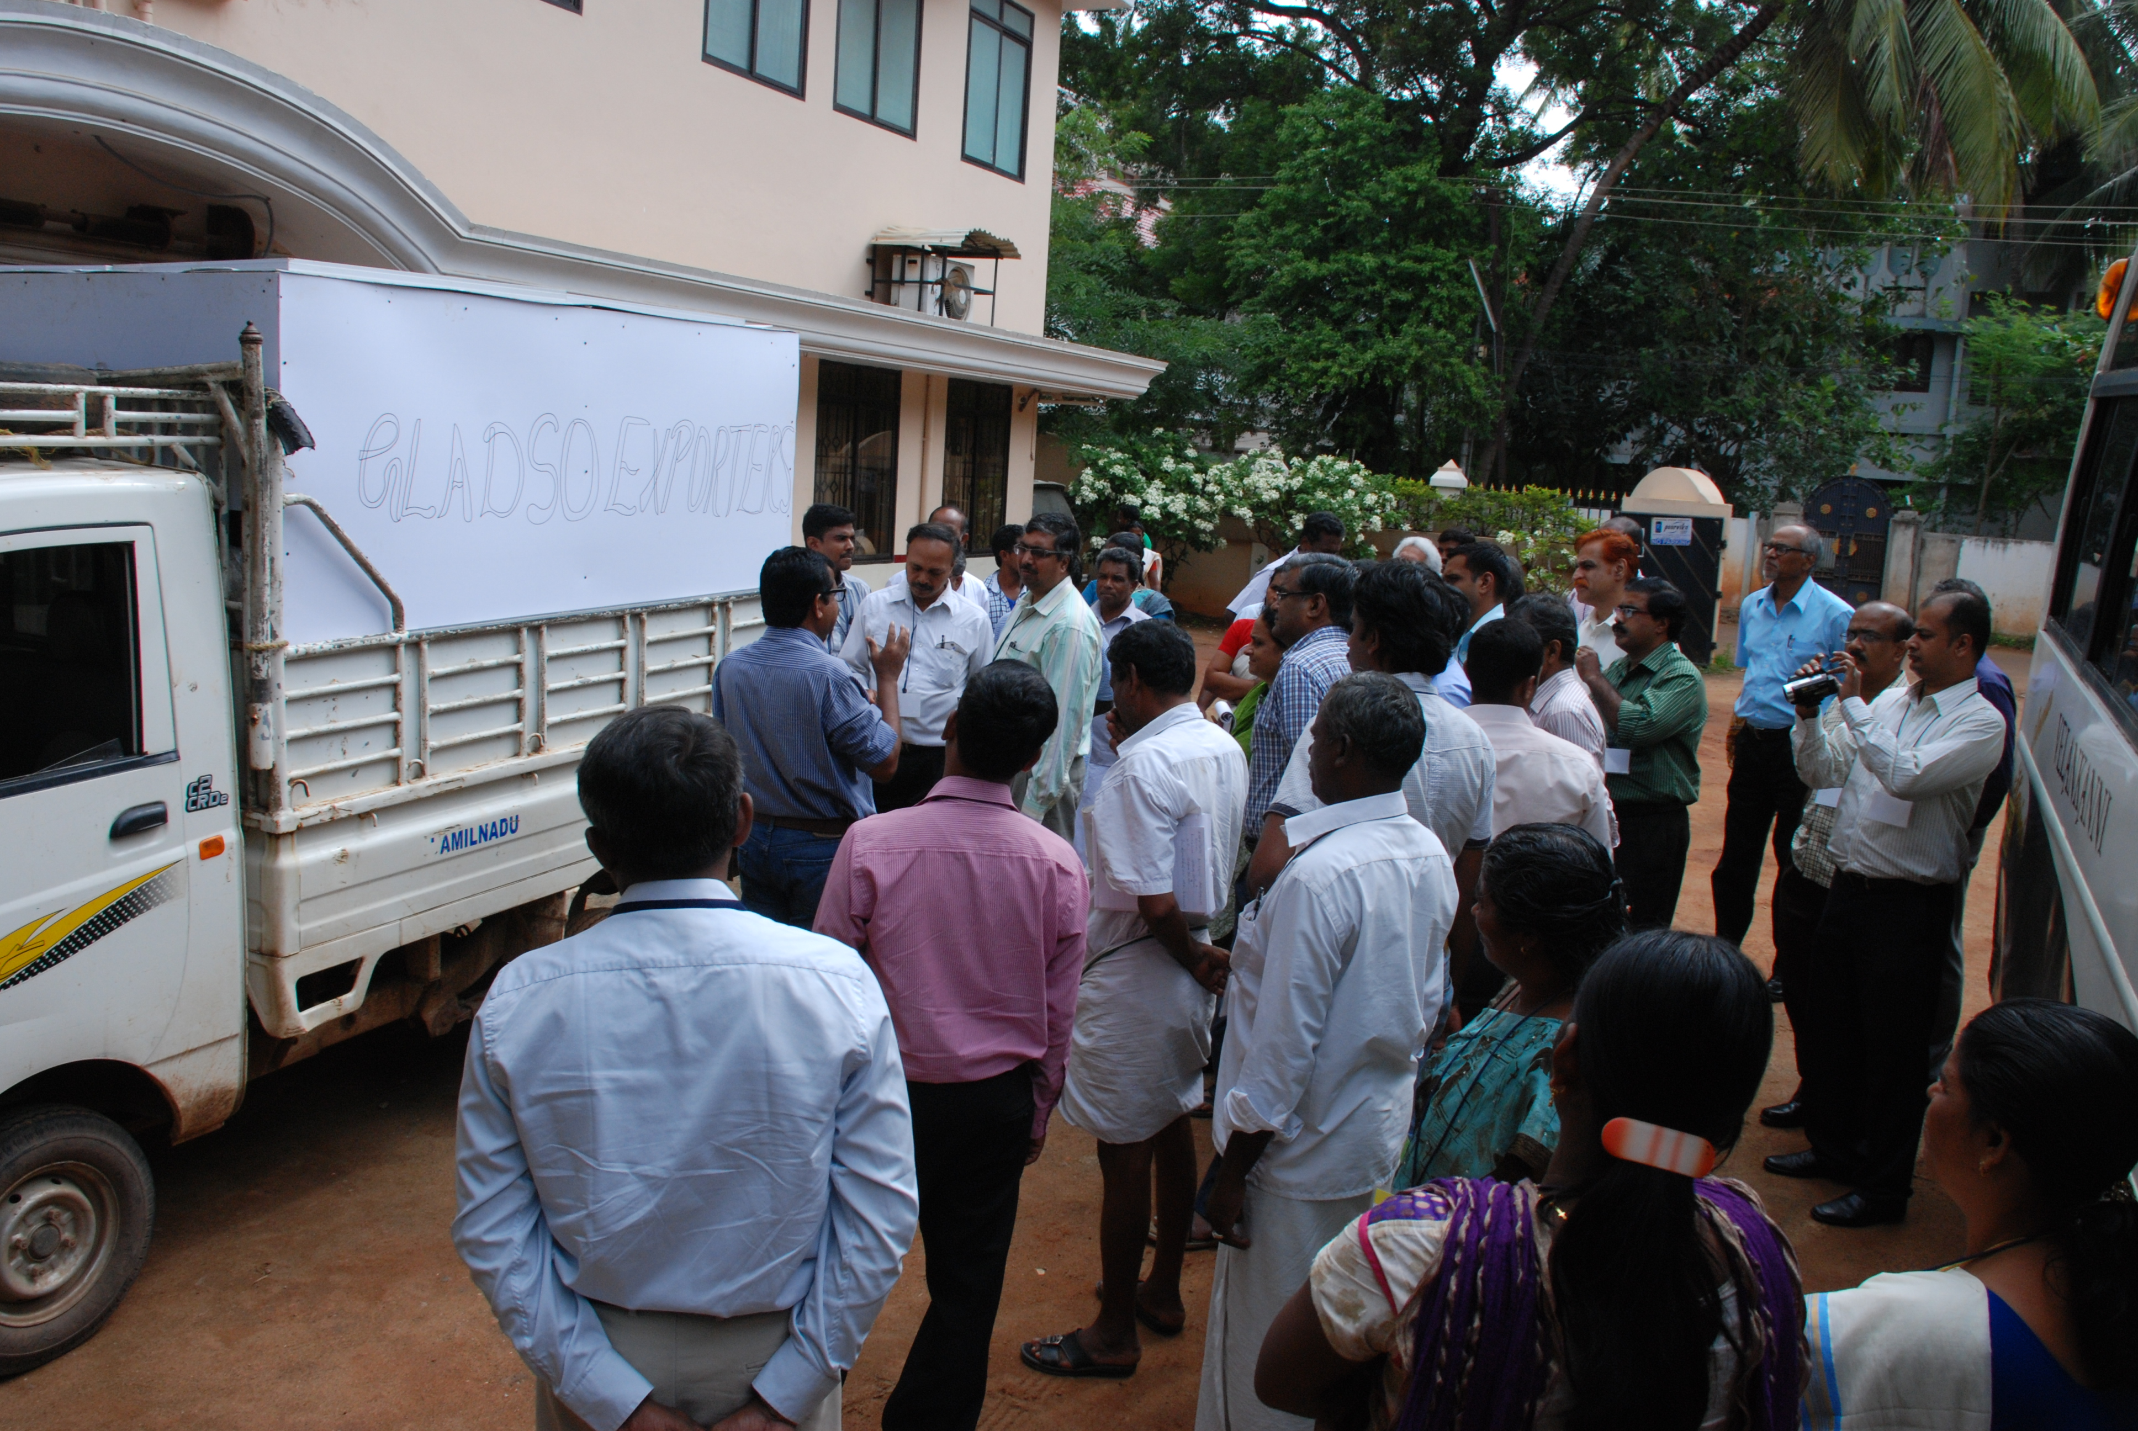
12-13 July 2013

Project assisted under NABARD SDC Rural Innovation Fund
National Strategic Consultation on Green Technology for Fisheries Sector 12 - 13 July 2013 Nagercoil, Tamil Nadu

